Final R Outputs

Jack Tomlon

2023-12-08

library(tidyverse)  
data <- read.csv("DataForFinal.csv")  
wrkData <- data %>% mutate(D = case_when(X6 == "straight" ~ 0,  
 X6 == "V" ~ 1))

# R outpout 1

fullModel <- lm(Y~ X1+X2+X3+X4+X5+D+I(D*X1)+I(D*X2)+I(D*X3)+I(D*X4)+I(D*X5), data= wrkData)  
summary(fullModel)

##   
## Call:  
## lm(formula = Y ~ X1 + X2 + X3 + X4 + X5 + D + I(D * X1) + I(D *   
## X2) + I(D * X3) + I(D * X4) + I(D * X5), data = wrkData)  
##   
## Residuals:  
## Min 1Q Median 3Q Max   
## -3.6366 -0.8764 -0.2712 0.5591 5.0546   
##   
## Coefficients:  
## Estimate Std. Error t value Pr(>|t|)   
## (Intercept) 26.73720 24.01269 1.113 0.2757   
## X1 -8.28079 9.81026 -0.844 0.4063   
## X2 -0.05498 0.05340 -1.030 0.3127   
## X3 1.66594 2.99899 0.555 0.5833   
## X4 0.26835 0.19818 1.354 0.1874   
## X5 -0.38290 0.89631 -0.427 0.6728   
## D 45.11459 24.43486 1.846 0.0763 .  
## I(D * X1) 2.56295 10.36230 0.247 0.8066   
## I(D * X2) 0.08974 0.05833 1.539 0.1360   
## I(D * X3) -3.47691 3.12621 -1.112 0.2762   
## I(D * X4) -0.42313 0.20391 -2.075 0.0480 *  
## I(D * X5) -0.08113 0.95263 -0.085 0.9328   
## ---  
## Signif. codes: 0 '***' 0.001 '**' 0.01 '*' 0.05 '.' 0.1 ' ' 1  
##   
## Residual standard error: 2.076 on 26 degrees of freedom  
## Multiple R-squared: 0.9294, Adjusted R-squared: 0.8995   
## F-statistic: 31.1 on 11 and 26 DF, p-value: 3.685e-12

plot(fullModel, 2)

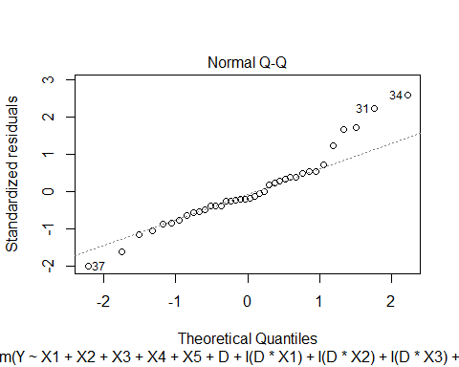

plot(fullModel, 1)

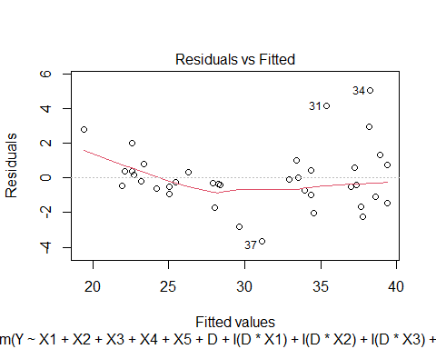

shapiro.test(resid(fullModel))

##   
## Shapiro-Wilk normality test  
##   
## data: resid(fullModel)  
## W = 0.93886, p-value = 0.03848

# R output 2

library("MASS")  
  
z <- boxcox(fullModel, plotit=T, lambda= seq(-3, -1, by=0.5))

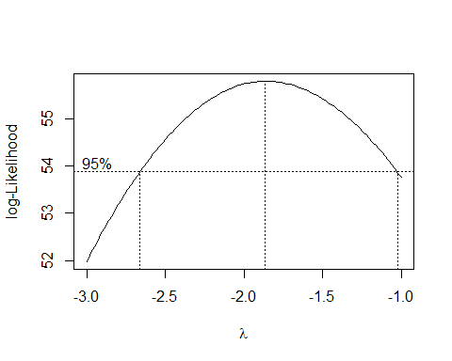

index <- which(z$y == max(z$y))  
lambda <- z$x[index]  
lambda

## [1] -1.868687

boxCoxModel<- lm(Y^(-1.8)~X1+X2+X3+X4+X5+D+I(D*X1)+I(D*X2)+I(D*X3)+I(D*X4)+I(D*X5), data= wrkData)  
summary(boxCoxModel)

##   
## Call:  
## lm(formula = Y^(-1.8) ~ X1 + X2 + X3 + X4 + X5 + D + I(D * X1) +   
## I(D * X2) + I(D * X3) + I(D * X4) + I(D * X5), data = wrkData)  
##   
## Residuals:  
## Min 1Q Median 3Q Max   
## -3.284e-04 -1.047e-04 1.500e-07 9.383e-05 3.140e-04   
##   
## Coefficients:  
## Estimate Std. Error t value Pr(>|t|)   
## (Intercept) 5.129e-03 2.054e-03 2.498 0.019162 *   
## X1 2.192e-03 8.390e-04 2.613 0.014734 *   
## X2 9.480e-06 4.567e-06 2.076 0.047966 *   
## X3 -5.427e-04 2.565e-04 -2.116 0.044101 *   
## X4 -5.986e-05 1.695e-05 -3.531 0.001566 **   
## X5 -3.652e-05 7.666e-05 -0.476 0.637762   
## D -8.044e-03 2.090e-03 -3.849 0.000692 ***  
## I(D * X1) -1.698e-03 8.863e-04 -1.916 0.066447 .   
## I(D * X2) -1.457e-05 4.989e-06 -2.920 0.007139 **   
## I(D * X3) 9.153e-04 2.674e-04 3.423 0.002060 **   
## I(D * X4) 8.143e-05 1.744e-05 4.669 8.05e-05 ***  
## I(D * X5) 8.519e-05 8.148e-05 1.046 0.305403   
## ---  
## Signif. codes: 0 '***' 0.001 '**' 0.01 '*' 0.05 '.' 0.1 ' ' 1  
##   
## Residual standard error: 0.0001775 on 26 degrees of freedom  
## Multiple R-squared: 0.9715, Adjusted R-squared: 0.9594   
## F-statistic: 80.5 on 11 and 26 DF, p-value: < 2.2e-16

plot(boxCoxModel, 2)

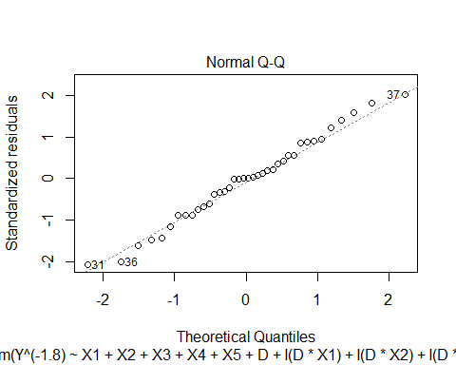

plot(boxCoxModel, 1)

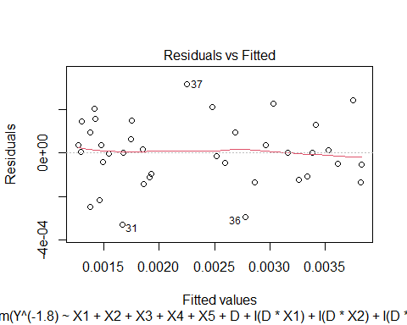

shapiro.test(resid(boxCoxModel))

##   
## Shapiro-Wilk normality test  
##   
## data: resid(boxCoxModel)  
## W = 0.98589, p-value = 0.9045

# R output 3

emptyModel <- lm(formula = Y ~ 1, data = wrkData)  
forwSelAIC <- step(object= emptyModel, scope= list(upper= fullModel), direction= "forward", k= 2, trace= FALSE)  
  
backSelAIC <- step(object= fullModel, scope= list(lower= emptyModel), direction= "backward", k= 2, trace= FALSE)  
  
stepwiseAIC <- step(object= emptyModel, scope= list(upper= fullModel), direction= "both", k=2, trace= FALSE)  
  
forwSelAIC

##   
## Call:  
## lm(formula = Y ~ X1 + X2 + X4 + I(D * X3) + X3 + X5 + I(D * X4),   
## data = wrkData)  
##   
## Coefficients:  
## (Intercept) X1 X2 X4 I(D * X3) X3   
## 71.27905 -5.13336 0.03011 -0.04265 1.47282 -3.19532   
## X5 I(D * X4)   
## -0.49480 -0.11550

backSelAIC

##   
## Call:  
## lm(formula = Y ~ X1 + X2 + X4 + X5 + D + I(D * X2) + I(D * X3) +   
## I(D * X4), data = wrkData)  
##   
## Coefficients:  
## (Intercept) X1 X2 X4 X5 D   
## 36.99619 -5.70599 -0.04258 0.19927 -0.48212 35.07728   
## I(D * X2) I(D * X3) I(D * X4)   
## 0.07739 -1.79989 -0.35480

stepwiseAIC

##   
## Call:  
## lm(formula = Y ~ X1 + X2 + I(D * X3) + X3 + X5 + I(D * X4), data = wrkData)  
##   
## Coefficients:  
## (Intercept) X1 X2 I(D * X3) X3 X5   
## 70.43200 -5.71418 0.03166 2.10963 -3.73034 -0.43744   
## I(D * X4)   
## -0.14864